THE REPORT FOR OOP LAB 2

Part 3: Use case diagram

Part 4: UML Class diagram

Part 5: Create Aims class

Part 6: Create the DigitalVideoDisc class and its attributes

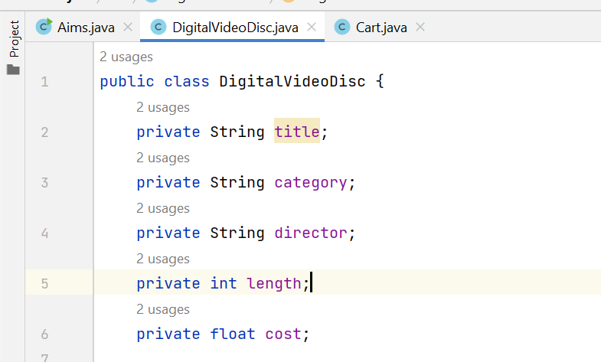

Part 8: Create accessors and mutators for the class DigitalVideoDisc

**Question:** - If you create a constructor method to build a DVD by title then create a constructor method to build a DVD by category. Does JAVA allow you to do this?

**Answer:** No, since we create a constructor method with only category attribute, it will have the same method signature as DigitalVideoDisc(String title) constructure. If that happens, the program will be confused when an object is create with the syntax like: DigitalVideoDisc opt = new DigitalVideoDisc(“Happy”);

Part 9: Create the Cart class to work with DigitalVideoDisc

1. Cart class

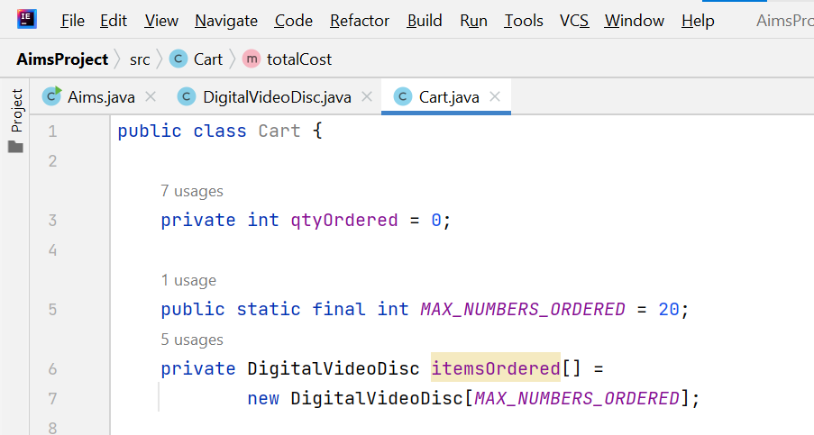

1. addDigitalVideoDisc(DigitalVideoDisc disc) method

1. removeDigitalVideoDisc(DigitalVideoDisc disc)

1. totalCost() method

Part 10: Create Carts of DigitalVideoDiscs

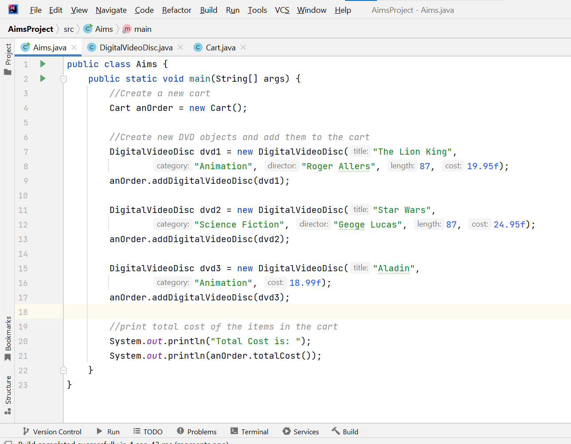

**The result:**

Part 11:

